AI2002 – Artificial Intelligence
Quiz – 4A

Name
Roll. No.
Section

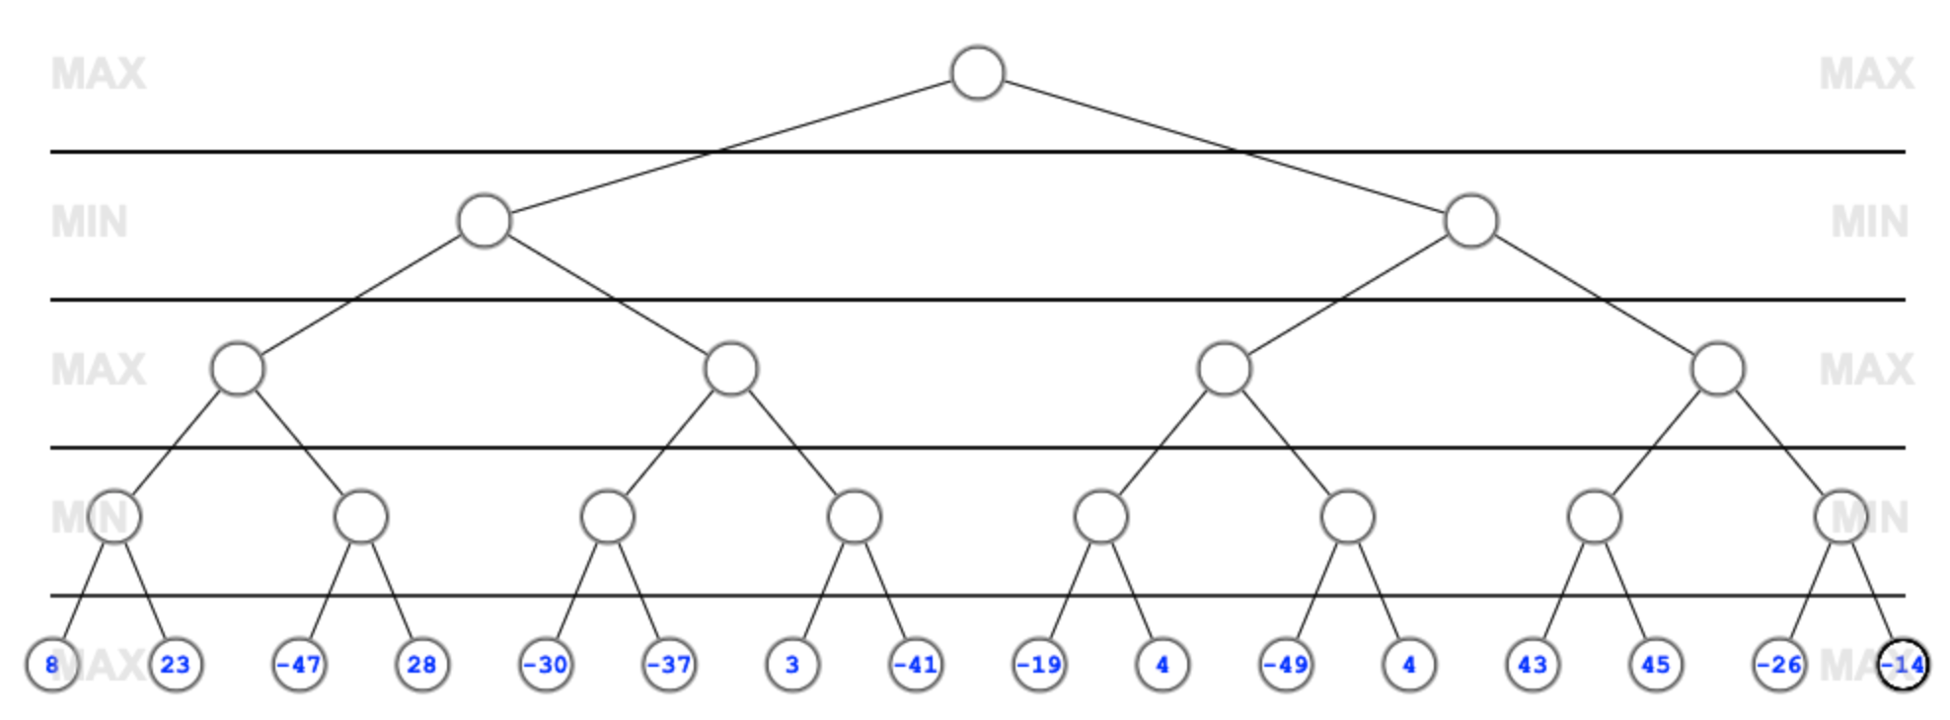

Solution



